JOINT INVESTIGATION VISIT TO THE FIRE EXPLOSION SITE ALONG NIGERIAN PETROLEUM STORAGE COMPANY PIPELINE, IJEGUN, LAGOS ON MONDAY 22ND JULY, 2019
1. FACILITY DETAILS:
- Name: Nigerian Petroleum Storage Company
- Status: Operational
- Location: Ijegun, Lagos
- Incident Site: Beside Haknims Gas Refill Shop, NPSC ROW, Ijegun
- Incident: Oil Spill
- Date of Occurrence: 4th July, 2019
- Cause: Vandalism
- Type of Product: PMS
2. PURPOSE OF VISIT: To assess the spill point with the aim of establishing the cause of incident, determine the impact of the explosion to the environment and also to conduct a damage assessment of the area.
3. DATE AND TIME OF VISIT:
Date: 22nd July, 2019
Time: 11:27hrs- 13:21hrs
4. NOSDRA TEAM:
- Mr. Abegunde V.O. Team leader
- Mrs. Chibogwu E Member
- Mr. Osunsade O.O Member
- Mr. Kwentor P. Member
- Mr. Ayeni I. Member

5. SITE CONTACTS
- Mr. Oyemala M.A HSE/NPSC 08032255432
- Mr. Okpokiri V. HSE/NPSC 07060620638
- Pastor Adewunmi Community Rep 07082421620
- Mr. Ajetunmobi Community Rep 08034621735
- Mr. Ajibola Olubunmi PENTAGON Security

6. BACKGROUND OF EVENT:
On Thursday, 4th July, 2019, there was breaking news of a fire explosion around Ijegun area of Lagos state. The Lagos zonal office placed a call through to NPSC area office at Mosimi to authenticate the information. The contact person confirmed the incident and the zonal head raised a team for immediate response to the site. The local intelligence gathered on site revealed the vandals were siphoning product (PMS) into a standby petrol tanker, in the process security personnel in the area released a gun shot while the vandals were trying to escape which then triggered a fire explosion due to Petrol spillage around the incident point. The fire explosion which started in the early hours of Thursday 4th of July 2019 was finally extinguished later in the evening same day.

7. OPENING BRIEF:
NOSDRA team arrive the incident site 11:21hours and introduction of both team was done immediately. The team leader stated the purpose of the visit, he then asked NPSC team if invitation was extended to the community and other key stakeholders. The head of NPSC said due to the security implications they decided not to formally invite the community, however the Department of Petroleum Resources (DPR) were invited but did not show up at the site.
He then went on to show the team the actual spill point, explaining that they were able to repair the damaged section shortly after the fire was put out hence the incident point has been backfilled. He pointed out that when they finally assessed the spill point, they saw an industrial valve with three outlets which was used by the vandals for siphoning the product into a standby tanker.
The team thereafter proceeded to conduct a damage assessment and determine the environmental impact of the fire explosion in the area.

8. SITE INSPECTION:
Observations:
- Spill point was beside a burnt petrol tanker,
- There was no pungent smell of PMS in the area,
- A burnt hilux vehicle belonging to RRS Lagos Police Command was sighted close to the spill point,
- The NPSC official showed the team a picture of the three outlet valve used to siphon the Product (PMS) after the breaking the pipeline,
- Ijegun Community primary school along Isolo road, Ijegun was affected by the fire,
- Essential properties like residential buildings, roadside shops, Transformer, several vehicles were damaged due to the explosion,

- Two sections of the pipeline were exposed along Ijedodo road, about 600m from the spill point,
- The three affected streets (Irede Street, Tijani Awotunde Street, and Ilero Avenue) were assessed accordingly,
- The canal and vegetation of Ilero Avenue was negatively impacted by the inferno.
Findings:
- The community has written a letter to Lagos State House of Assembly and NNPC seeking for compensation for properties lost (as confirmed by a community representative met on site),
- An elderly man informed the team about the death of some people in a building along Ilero Avenue due to suffocation of smoke,

9. GPS READINGS:

- Spill point: N 06⁰ 30’ 59.6”
E 003⁰ 15’ 37.9”
- Damaged point of the pipeline: N 06⁰ 30’ 59.7”
E 003⁰ 15’ 37.8”

- Burnt Tanker: N 06⁰ 30’ 59.4”
E 003⁰ 15’ 37.6”

- Exposed pipeline along Ijedodo road (1) N 06⁰ 30’ 59.4”
E 003⁰ 15’ 37.6”

- Exposed pipeline along Ijedodo road (2) N 06⁰ 30’ 54.6”
E 003⁰ 15’ 36.6”

10. PHOTOGRAPHS: Attached

11. CLOSING BRIEF:
The team leader appreciated NPSC and the community representative for their cooperation; he stated the need for a community sensitization in order to facilitate effective information sharing when suspicious movement is observed in the area. The visit ended 1321hours.

12. TIME LOG:
TIME LOG | ACTIVITY
1032hours | NOSDRA team departed from Lagos Zonal Office
1127hours | Team arrived at Ijegun
1321hours | Team departed from Ijegun
1623hours | Returned back to the office

13. RECOMMENDATIONS:
The management of Nigeria Ports Authority should be directed to:
- Submit Form A and incident report to the Agency.
- Consider deeper burial of their pipeline particularly the section along Ijedodo road to prevent easy access by intending vandals and damage due to vehicular activities in the area.
- Liaise with relevant stakeholders particularly Lagos State government as a matter of urgency in order to relocate all public schools built close to pipeline ROW to avoid unforeseen disaster.
- Organize a community sensitization program to facilitate information sharing for effective and efficient response operation.
14. NAMES AND SIGNATURE:
Mr. Abegunde V.O. ……………………..……………………………………
PES

Mrs. Chibogwu E. ………….………………………………………..........
SES

Mr. Osunsade O.O …………….……………………………………….........
SES

Mr. Kwentor P. …………………………………………………………….
ES I
Mr. Ayeni I. ………………………………………………………………
LOS

PICTURES
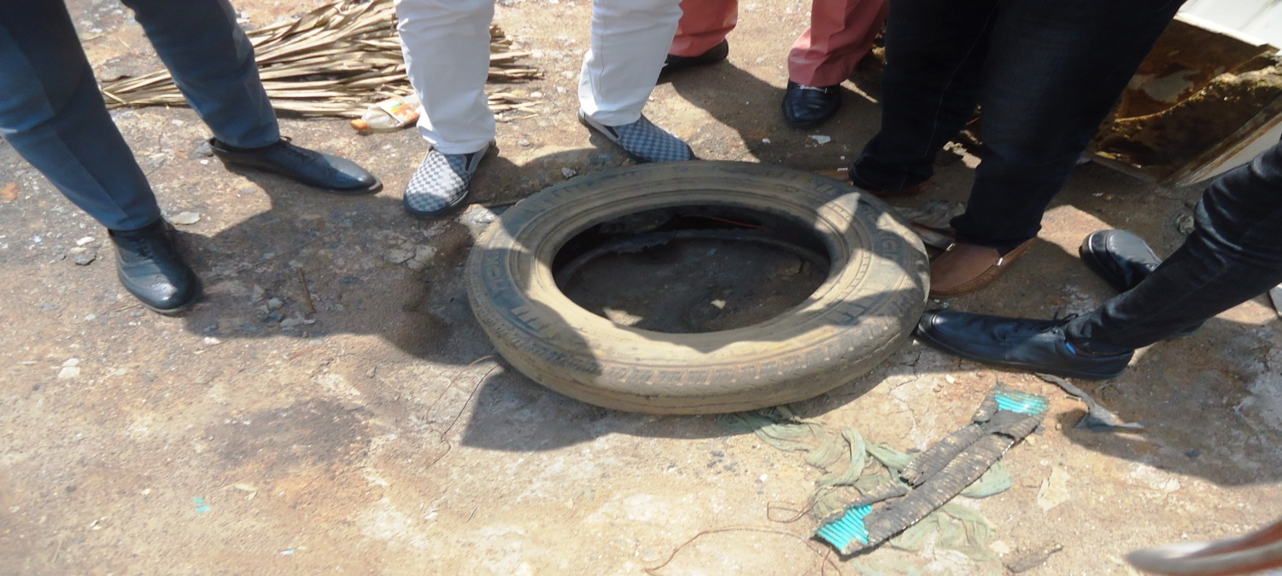
Fig 1: Incident point already backfilled after repairs
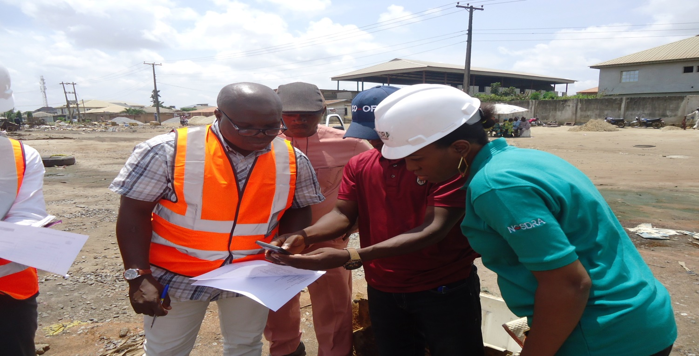
Fig 2: NPSC official showing NOSDRA team a photograph image of three outlet Valve used by vandals

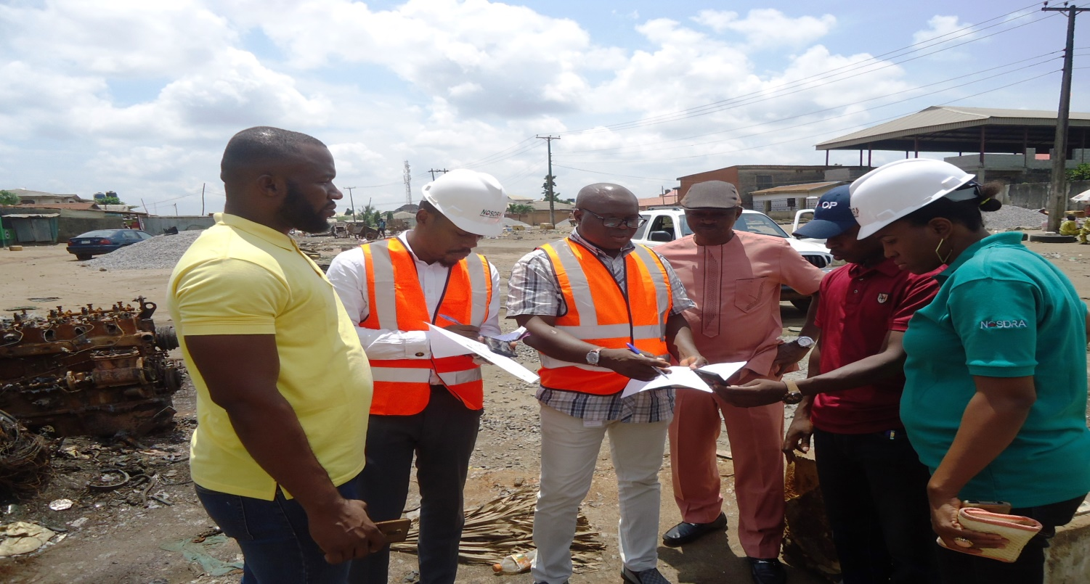
Fig 3: NOSDRA &NPSC team during the JIV
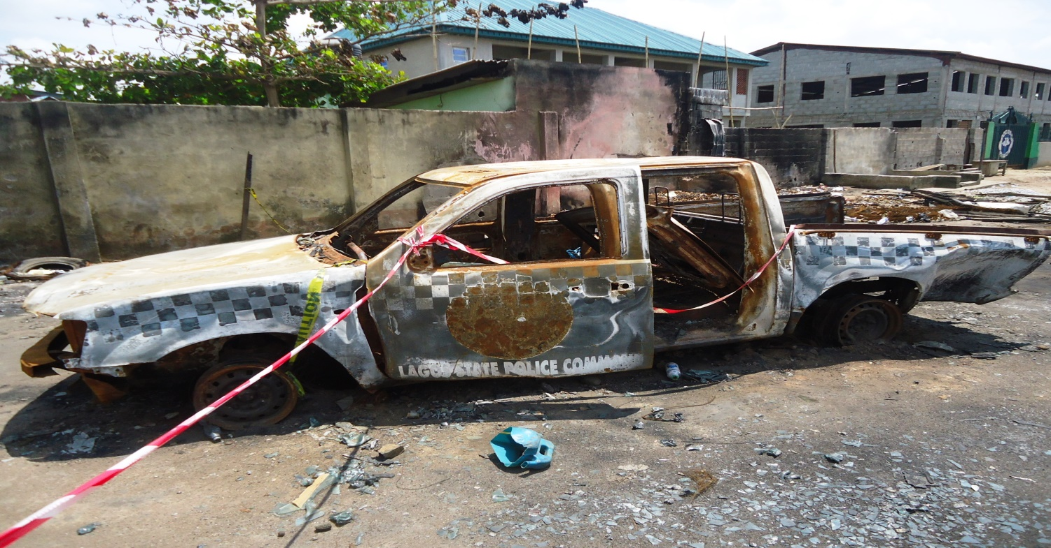
Fig 4: Burnt RRS Lagos State Police Command Hilux by the spill point

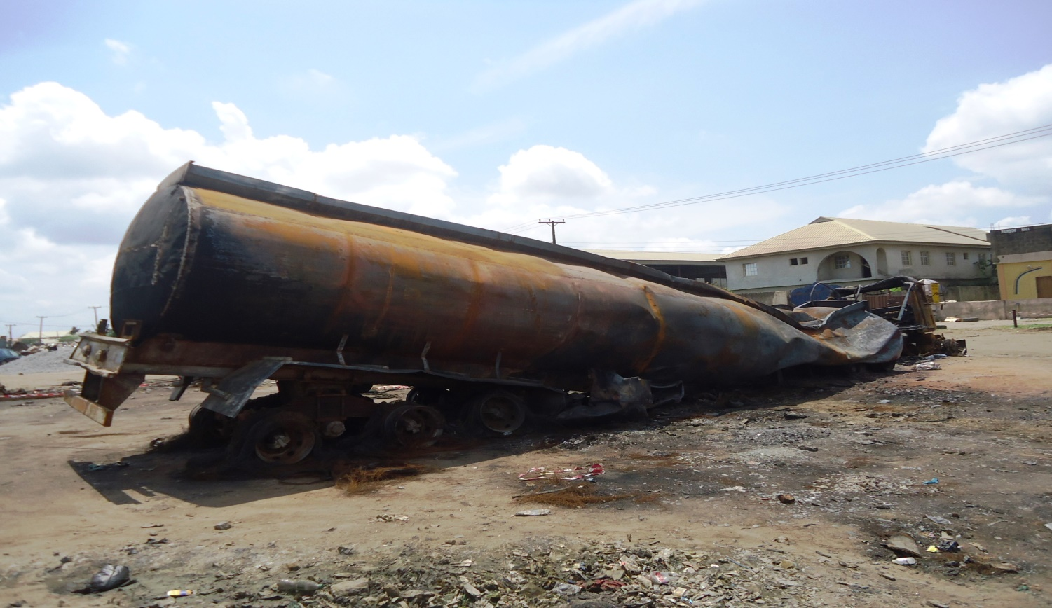
Fig 5: Burnt Petrol Tanker used by Vandals for siphoning Product
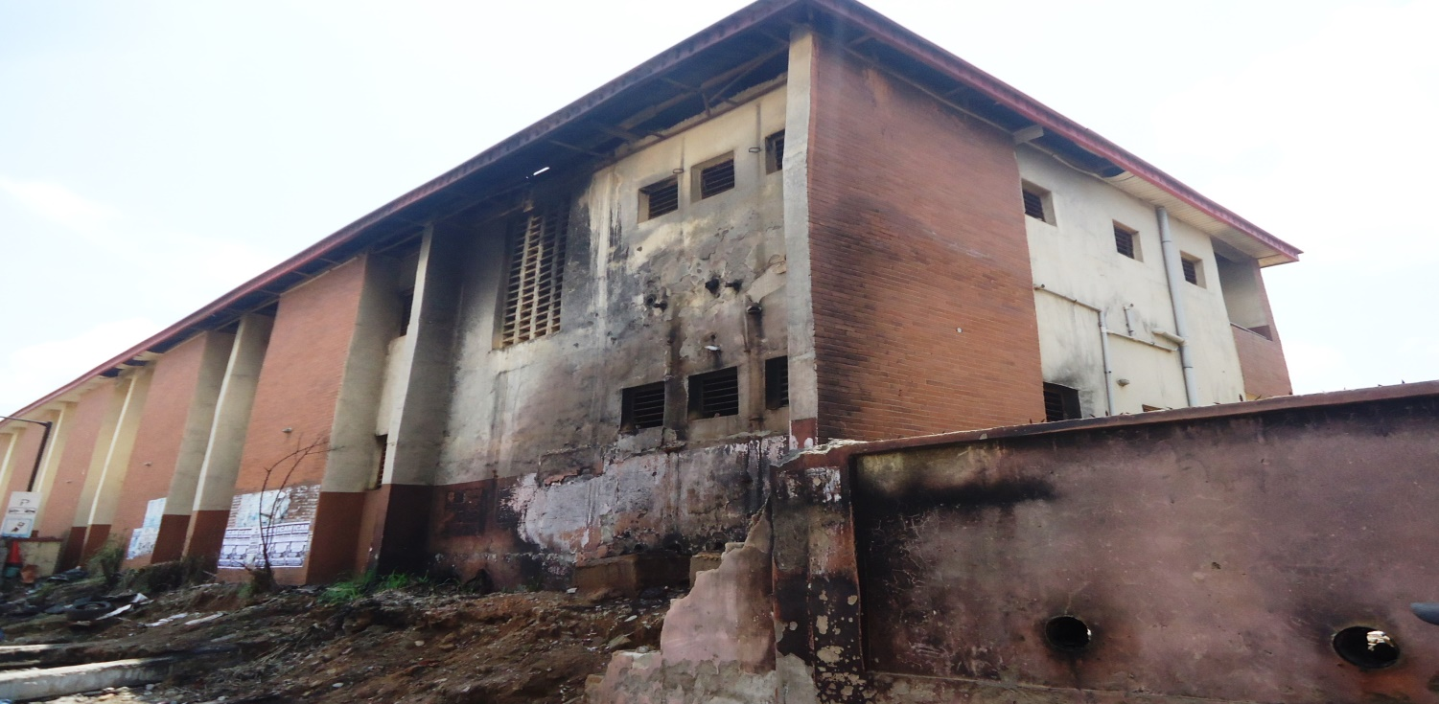
Fig 6: Damaged Ijegun Primary school along Isolo road, Ijegun

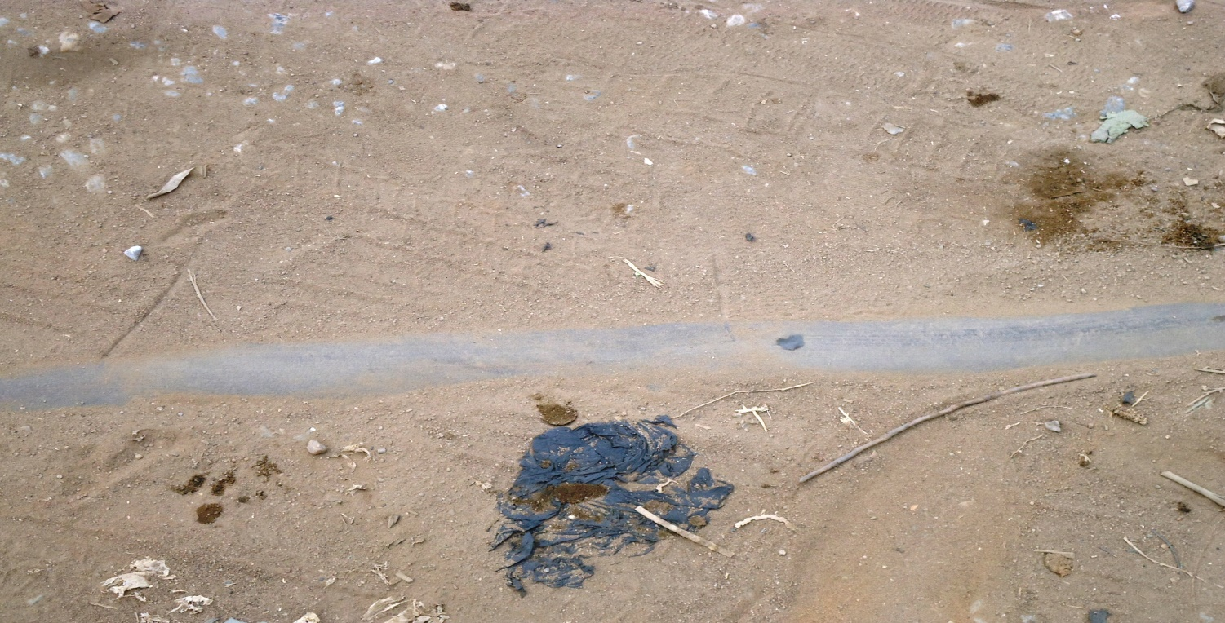
Fig 7: Showing exposed section of the Pipeline along Ijedodo road, Ijegun
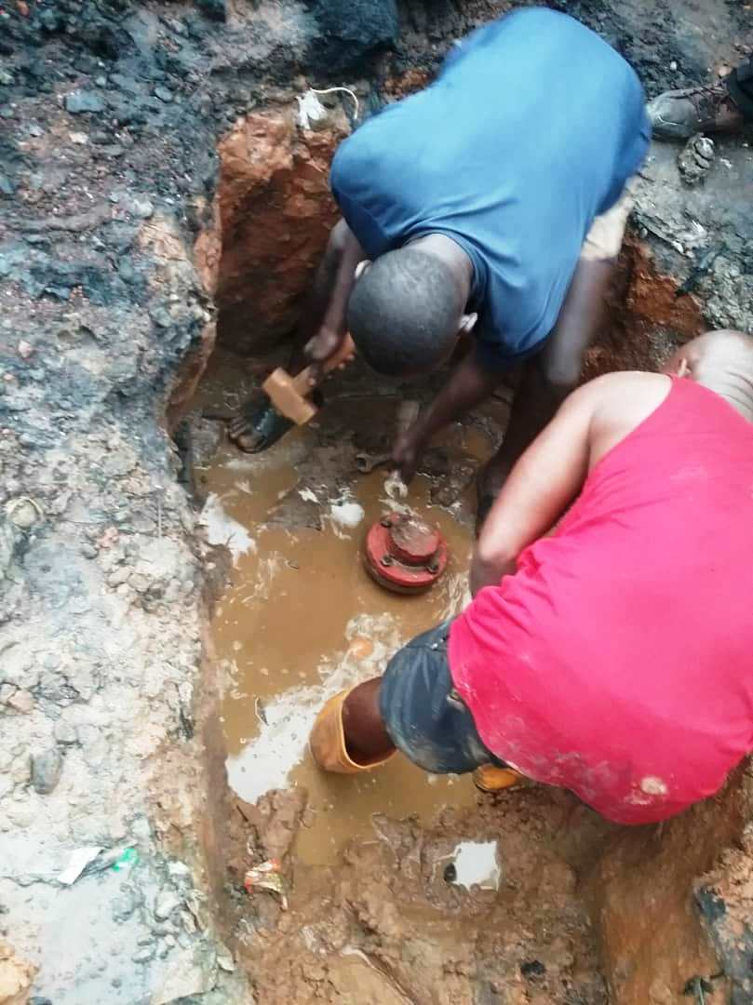
Fig 8: Excavation of incident point after the fire has been extinguished

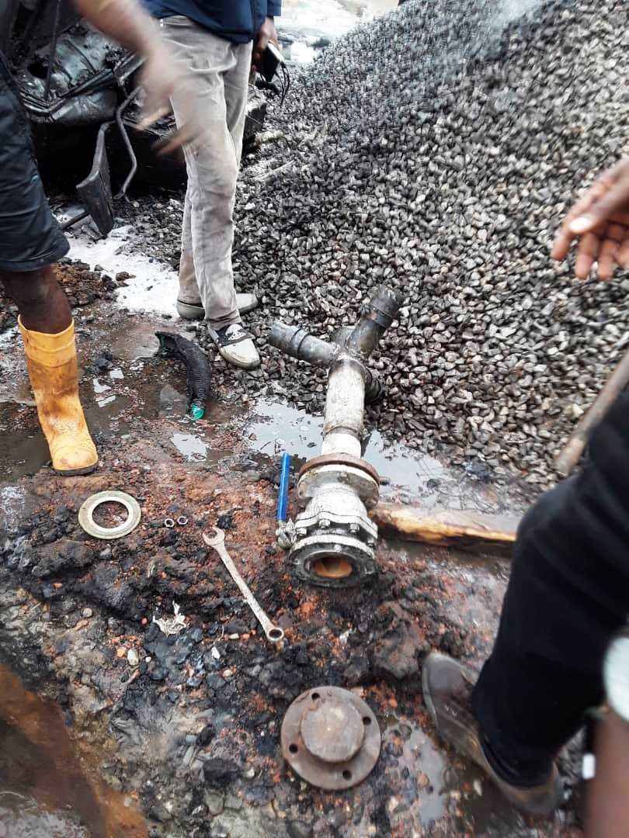
Fig 9: Showing three outlet valve used by the Vandals to siphon the product

